Cause and Effect | Compare and Contrast | Sequence | Problem and Solution | Description
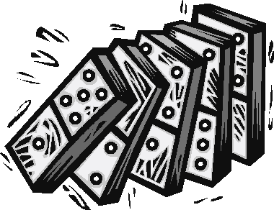 | 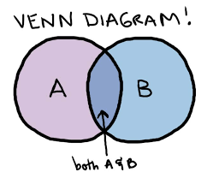 | 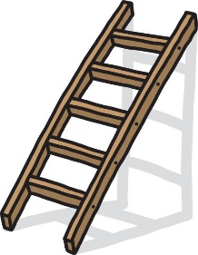
Signal Questions
What happened?  Why did it  happen? What  caused it to  happen? | What things are  being compared? In what ways are  they alike? In  what ways are  they different? | What items,  events, or steps  are listed? Do they have to happen in  this order? Do  they always happen  in this order? | What is the problem? Why is this a problem? Is anything being done to try to solve the problem? What can be done to solve the problem? | What specific topic, person, idea, or thing is being described? How is it being described (what does it look like, how does it work, what does it do, etc.)? What is important to remember about it?
Signal Words
 | Same as  Similar  Alike  As well as  Not only…but also  Both  Instead of  Either…or  On the other hand  Different from  As opposed to |  | Question is…  Dilemma is…  The puzzle is…  To solve this…  One answer is…  One reason for  the  problem is… | For instance  Such as…  To begin with  An example  To illustrate  Characteristics  *Look for the  topic word (or a  synonym or  pronoun) to be  repeated

